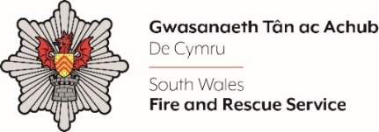
Contracts and E Procurement Officer

Please complete the form below in FULL adhering to the 500-word limit for each of the shortlisting criteria (i.e. max of 1500 words). Then save in a Word document format and upload to the ‘supporting evidence’ section of the online application.

Please note that for shortlisting purposes we will be removing ‘Name’ and ‘National Insurance number’ and each candidate will be provided with a candidate number for anonymised shortlisting.

For any queries please contact recruitment@southwales-fire.gov.uk or for internal queries, please contact us via 24/7

Anonymised Candidate Number (to be completed by FRS HR team)
Question 1: Please outline your experience in procurement within the public sector?
Question 2: Describe your experience of leading high-value procurement exercises, both independently and as part of a wider project team?
Question 3: Please tell us about how you communicate effectively both orally and in writing with a wide range of audiences?

Question 4: Please tell us about your ability to understand and apply relevant information to make appropriate decisions that reflect key priorities and requirements?

Closing date – 25.07.2025 by Midday

