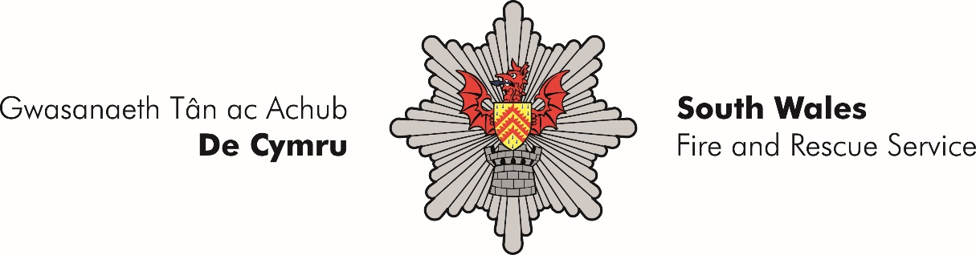
Wholetime Duty System
Group Manager (B) Promotional Selection Process 2022
External Advert

South Wales Fire and Rescue Service (SWFRS) are an innovative and inspiring organisation who are seeking to appoint to the role of Group Manager B (Flexible Duty). The post holder(s) will contribute to the culture and values of South Wales Fire & Rescue Service, promoting its role in the context of a unique public service infrastructure within Wales.

Candidates will need to demonstrate a clear understanding of the current issues facing the Service and be able to demonstrate effective planning, organisational and people skills. These are challenging positions, calling for leaders with high levels of interpersonal skills who can develop relationships and influence change. The ability to work both proactively and reactively as needs dictate is essential. SWFRS are seeking applicants who are dedicated in helping to shape and lead the organisation forward within such a changing climate.

Eligibility

Group Manager A or B:
- who have been both substantive and competent Group Managers (A or B) for a minimum of 12 months at the close of the advertisement (4th November 2022, midday).

- Applicants must also be in possession of an ICL3 pass (SFJ Level 6) prior to commencement of interviews (w/c 12th December 2022). Candidates who have gained their ICL3 qualification externally will still have to attend a SWFRS internal confirmation assessment of their ICL3 competency against National Occupational Standards for Level 6. South Wales Fire and Rescue Service will offer such assessments w/c 21st November 2022 for all applicants that go through the sift and need to undertake the assessment.

Application

External candidates who meet the above criteria, will be required to submit an Application Form which is in two parts. Part 1 is to be completed via the online system and then part 2 will need to be provided as an attachment to part 1 and submitted together.

Selection Process

Internal candidates will be required to complete Part 1 of the application only (online application form) as they have already undertaken part 2 as part of their GMA process.

Full details of the advert can be found: https://www.southwales-fire.gov.uk/working-with-us/latest-vacancies/

The Selection Process

Candidates who are successful at scrutiny will be invited to a selection process w/c 12th December 2022, this will be set against the Group Manager Role Map and the NFCC Leadership Framework.

The Selection Process will consist of an interview with questions designed to assess a robust knowledge and understanding of the complex matters affecting the Service. The Process will also involve an additional form of assessment eg presentation.
Full details of the Process will be provided nearer the date.

Timetable of Events

Stage | Deadline/Dates
Application Stage | 19th October 2022 to 4th November 2022
Application Deadline | 4th November 2022 (12 midday)
Sift | w/c 7th November 2022
Incident Command Assessment (ICL3) | w/c 21st November 2022
Group Manager (B) Selection Interview | w/c 12th December 2022
Feedback | During December

Please be aware that this is a highly competitive process and only the highest performers will progress through each stage.

Language Preference

You have the opportunity to receive correspondence and the delivery of assessments associated with the Group Manager (B) selection promotional process through the medium of either Welsh or English. Appropriate provisions will then be put into place for candidates.

Please note:
Application forms received after the closing time will not be accepted. You are advised to ensure sufficient time to complete the Application form Stage.

Any further enquiries during this process should be directed to:
assessment@southwales-fire.gov.uk.

Or contact
Deb Doel on 07795353794

Application (part1): online form
Attachments: Application form (part 2) – additional information and NFCC framework

