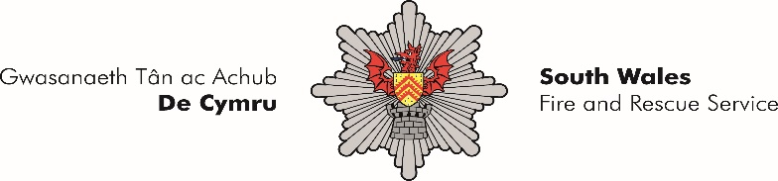

planning, performance and risk officer
GRADE 11, SALARY: from £32,234 to £32,910 Pro-Rata
Two year fixed term to cover career break from 01st April 2022
3 days per week to be agreed on appointment
Post Number: NU190

An exciting opportunity has arisen within the Service Performance and Communications Department based at Fire Service Headquarters, Forest View Business Park, Llantrisant for the role of Planning, Performance and Risk Officer.

As part of the Planning, Performance and Risk Team, you will be responsible for the development and continuous improvement of our processes and management information systems, working on associated strategies relating to Business Planning, Performance Management, Risk and Audit. This will ensure the organisation is effectively managing and reporting its performance in line with all relevant legislative requirements.

Building relationships with internal and external stakeholders at all levels, you will have experience of strategic planning and project/change management to deliver measurable service improvement, providing advice and guidance to senior management and directorates.

Welsh language skills are desirable but not essential for this post.

More details in relation to this position can be found in the Job Description and Person Specification. Should you have any additional enquiries, you are invited to contact the Line Manager, Suzanne Absalom by e-mailing s-absalom@southwales-fire.gov.uk.

An Application Form, Job Description and Person Specification can be downloaded from the Working for Us / Latest Vacancies page of our website at www.southwales-fire.gov.uk

Completed applications should be returned to: The Recruitment and Assessment Team, South Wales Fire & Rescue Service Headquarters, Forest View Business Park, Llantrisant, CF72 8LX or via email: recruitment@southwales-fire.gov.uk

The closing date for receipt of application forms is 24/03/2022.

All documentation is available in both in English and in Welsh and we welcome communication in either language. Applications submitted in Welsh will not be treated less favorably.

Please note that all salaries are subject to job evaluation.

South Wales Fire and Rescue Service believes in the real value of having a diverse workforce and we proactively want to encourage applicants from all sectors of our community to apply.

